Implementing Automatic Bill Payments in Fi App

Problem

Users are unable to add their bills and set up automatic payments in the app. Missing out on time-sensitive payments frustrates the users and can cost them extra bucks to settle them. Keeping track of bills and payments in one place where they hold money seems to be more relevant for users.

Goals

* Become the Go-to app for bill payments and make Fi even more useful
* Ensure better user experience and ease of use
* Win over competition
* Generate revenue

Why build it?

* Usage of online payments
  + Our customer base comprises millennials and Gen-Z who primarily make most of their transactions online
  + Cashless transactions are considered to be more secure and easier to our users and save them a lot of time
  + It helps them keep track of their spending which is rather difficult when paying physically with cash.
* Fi Bank’s OKR
  + An increase in transactions with Fi Debit cards would translate to an increase in revenue through transaction fees.
  + We haven’t started any monetization effort till FY 21 and starting a revenue stream would be one of Fi’s key objectives this year.
* Request from Users
  + The ability to add bills and enable automatic payments has been a frequent request from users in our app review section.
  + Users feel that our product has more potential to help them manage their expenses and eases their job of tracking them with Ask Fi.
* Competition Parity
  + Based on the current market landscape our competitors have not implemented this feature and this can give us an edge over them.

Who’s it for?

* Big-time Spenders - People who have a number of bills to pay at the start of every month or over a cycle and usually find it difficult to remember them.
* Our primary focus, for now, would be to get in users from Tier 1 cities to start using our autopay feature where the adoption rate would be higher.

Success Metrics

* Increase in the number of monthly recurring transactions in the app by 20 % in the next 2 months after implementation
* Increase net revenue by 15% in the next 3 months after implementation
* 40 - 50 % of users should add at least one bill for auto payment within 2 months of implementation

Metrics to watch out for

* The ratio of people who use Automatic payments/ Total number of Fi users would give us the adoption rate of the feature
* Number of new user signups after implementation of the feature.
* Percentage of bill-based transactions in Fi per day, week and month.
* Number of unique bill-paying users per month
* Session duration for the feature to understand the usage of the product and see how many users bounced back or churned out.

Product Requirements

The primary outcome should be:

* It should be easy to set up and customize as per user requirements.
* Users should feel like trying the feature and at least add one bill for auto-payment.
* A lower transaction failure rate as we are already dealing with a lot of feedback on this issue.
* Users should feel better informed of the payments and bills in one place.

Home Page View

* Once the user opens the app, we can educate the user with a pop-up that informs about the new feature which can be closed manually by the user. This might be something we can try.
* With all other existing features, AutoFi should be placed in a prominent place as a highlighted feature with the text ‘new’ over it. Fewer actions to reach the feature would ensure a higher click-through rate.
* It should also be placed in the sliding transition of features that we can navigate from the home page. It should again be a swipe or two away to land on the feature.

Product Page View

* The product page should be simple and should have an image representing the product. We have implemented a good UX experience throughout the app and this should also add to it.
* We are making room for only 7 options for now, and they are the most [commonly paid bills](https://moneypremier.net/monthly-budget-for-middle-class-family-in-india/) by our targeted users:
  + DTH
  + Electricity
  + Water
  + Gas
  + Broadband
  + Rent Payment
  + Credit Card Payment
* The cognitive load for users should be very low, hence the icons for bills should be well spaced and easier for users to identify.
* The transition between selections should be a sliding motion which makes the navigation experience better.
* The overall number of steps to set up the bill payment should be as follows:
  + The user selects the type of bill eg: Electricity
  + The user has to select the Electricity Board, which can be defaulted based on the user’s location may be.
  + The user types in the consumer number, maybe help find the number from the email.
  + The bill gets synced, this shouldn’t take much time as users may drop off if it takes longer to sync.
  + User uses the slider to confirm the addition of the bill.
  + User gets asked if email and in-app notifications have to be turned on for auto-payments. [Users should find the whole flow to be smooth and that can trigger them to add another bill]
* The user is well informed of the data being fetched from the respective sites and used by Fi for making these payments. This information should be placed on the screen when the user tries to add the service provider for any of the bills.
* It is essential that we provide suggestions for any field to be typed in by the user. Like Bank Names, Electricity Board Names, and Broadband Provider Names. Names along with their icons let users easily identify the desired option and save time.
* The flow might differ a bit for each bill type, for credit card payment we can give the user the flexibility to select the amount and date at which it has to pay. We are trying to make sure that each flow has the right options to use.
* For Rent Payment, the user should be able to:
  + Give a name to the Landlord/ Select from existing people in the beneficiary list
  + Enter his/her UPI ID or add the bank account details
  + Enter the amount to be paid
  + Select the day on which the payment should be triggered every month
  + Slider action to confirm [Shows the overall details, might also show the time at which it would be debited]
* A message that pops up after adding the details can add as a delighter. Something like ‘ Ronaldo takes the penalty, not you anymore! [Chuckling emoji] ‘
* We can also help users get all subscription and monthly bill details using Ask Fi if they have given access to Gmail. It can be just a query like ‘Hey can you get me all my subscription info?’.
* The data should be at least 90% accurate for the user to get impressed and trust his/her data. This would cut down the steps to be taken by the user. The user would very likely add those bills as his job is already half done and people wouldn’t want to drop off when efforts from their end are lowered.
* Users should be able to raise tickets in the event of an incomplete transaction and follow up with the customer service team to resolve it as soon as possible.

View after adding bills

* The top portion of the page would have the usual widget which gives details such as:
  + Number of bills settled this month
  + Amount spent on bills[On top]
  + Savings made [ If a user creates a custom FIT rule based on this spending, then this data would be relevant to users]
* Beneath it, there would be an option for users to view the bills for the month. They can edit the rule set for the bills and can also delete them from there. The lower the effort is to customize, the user would appreciate the functionality.
* Ask Fi would serve the purpose of analyzing the spending on bills every month and give the user insights on any trend. Helping our users with money management is a key part of our product and Ask Fi can suggest saving X Rs if say Y Rs. has been spent more this month.

Screen Mocks

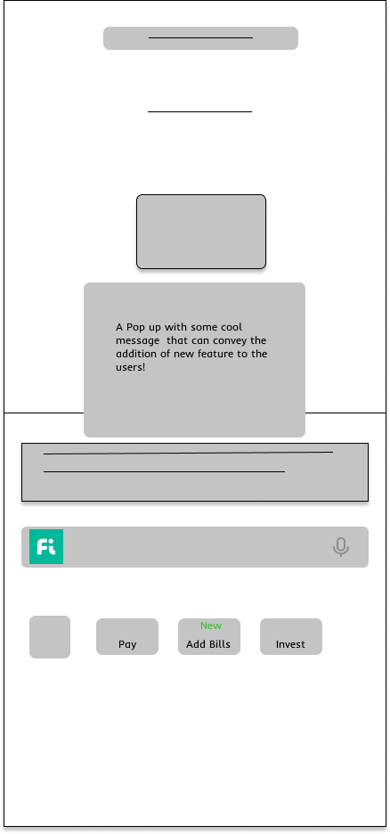

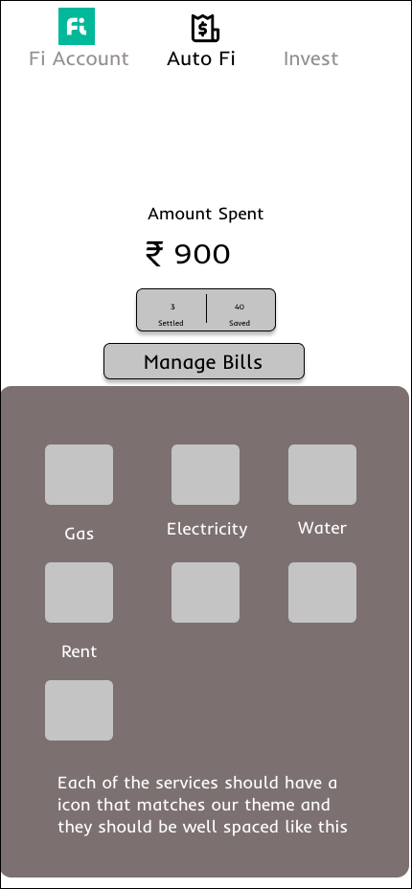

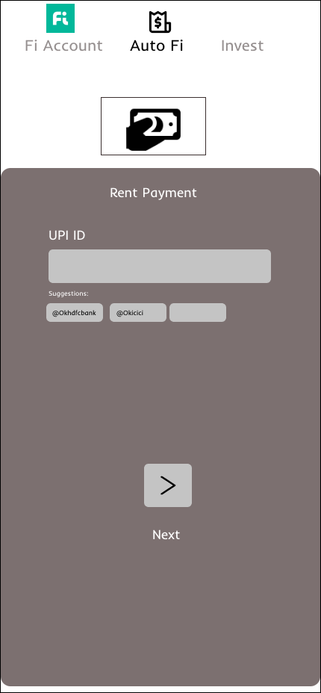

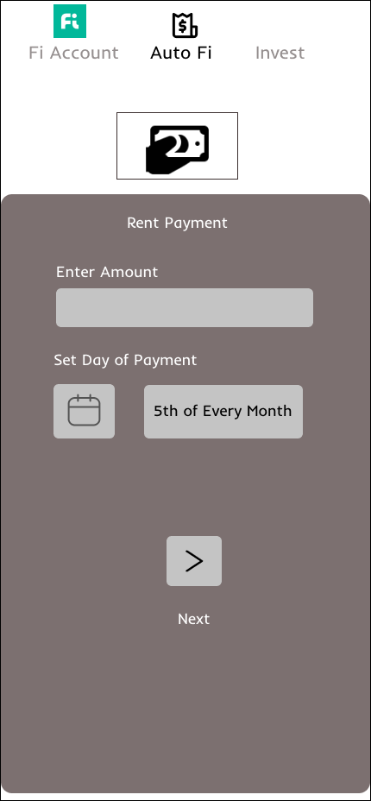

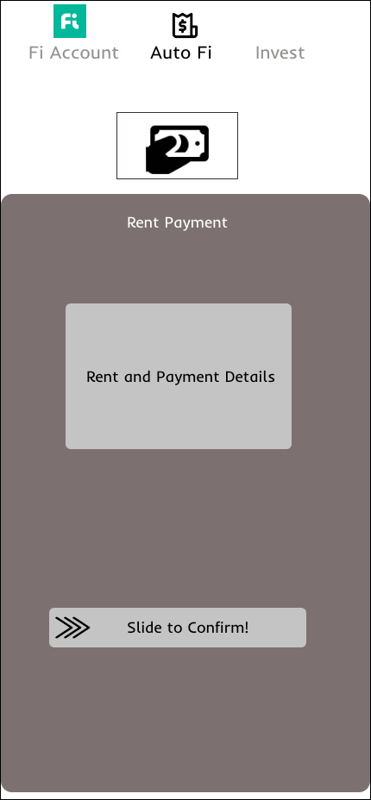

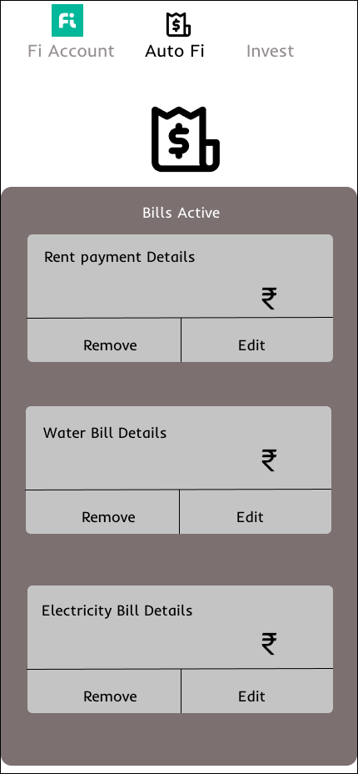

The mock screens depict the flow and the details discussed in the product requirement section.

How to educate customers about the feature?

* The onboarding flow for this feature would be made in the app.
* Engage with users in our social media handles and inform them about the new feature and it’s advantages
* Reach out to influencers and ideate about making reels about the feature
* Reach out to press contacts and get direct product feedback
* Use the Fi coins and fresh rewards as hooks to get users to start exploring and using the feature
* Email existing Fi users

Future Ideas

* Expand the type of bills that can be paid through the app such as loan payments, mobile recharge, FASTag, etc.
* Check for trial subscriptions through emails and notify the user about any forthcoming payments.

Milestones

| Items | Status | Date |
| --- | --- | --- |
| PM Spec v1 | Done | 15 May |
| Kick Off with Design | Ongoing | 20 May |
| Wireframes | Ongoing | 31 May |
| Feedback on Wireframes  & PM - Designer alignment | Ongoing | 6 June |
| Kick Off with Devs + QA + Design + Security Team + UX Writer | Ongoing | 10 June |
| Backend Tech Spec | Ongoing | 20 June |
| Frontend Tech Spec | Ongoing | 27 June |
| PM - Dev Huddle | Ongoing | 4 July |
| Spec Freeze (After iterations of scope cuts and creep based on Dev and Design discussions) | TBD[To Be Done] | 14 July |
| Design Freeze (with High fidelity designs shared on Zeplin) | TBD | 18 July |
| Roll Out Plan | Done | 22 July |
| QA (includes backward compatibility) | TBD | 1 August |
| Alerts for failure | TBD | 5 August |
| Analytics events | TBD | 11 August |
| Design Sign Off | TBD | 15 August |
| PM Sign Off | TBD | 22 August |
| QA Sign Off | TBD | 26 August |
| Demo to Stakeholders | TBD | 29 August |
| Ship on Prod | TBD | 5 September |

Risks and Mitigations

* Automating payments could put you at risk of overdraft in your account if you’re not keeping an eye on your balances.
  + Keep users notified about low balances before the day of payment arrives so that they are aware.
* Having an automatic payment returned for insufficient funds could lead to steep fees.
  + Better inform users about late fees if they don’t have sufficient balance in their account to perform automatic payments.
* If you’re paying using your credit card or debit card, you’ll need to remember to update your information when the card expires; otherwise, your automatic payment may not be processed.
  + Notify users if their card is expiring and make sure they replace them before the day of payment arrives
* Forgetting about an automatic bill payment you’ve put in place means you could continue to be charged for services that you no longer use.
  + Keep the user informed and check with the user on a regular basis about active/inactive services.